07-02-2013
Konrad Fiedler är en av studenter som deltar i EU-projektet South Baltic Training Programme. Han genomför 3-veckors praktik på Litorinas Båtbyggarlinje. Nu sitter vi i det lilla fikarummet på Stumholmen, en dag innan Konrads praktik avslutas, och pratar om hur han upplever den tiden som han har varit här.
Where are you from, Konrad?
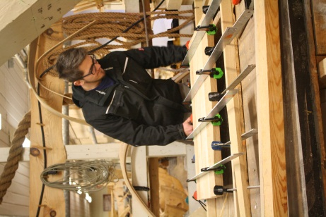
Bad Doberan in Germany. It is a small place near Rostock, a bit smaller than Kalskrona.

What do you do in your hometown?
I am at my 1st year at a carpentry school. I learn how to make furniture.

Interesting. Can you tell me more about it?
Sure. It is a 3-year course. During the first year you learn how to make simple furniture with your own hands. After that you get a permission to use machines. We have 2 weeks of learning and 4-5 weeks of training at some furniture company. Then back to school again and then training in a different place.

Sounds like you never get bored. And what are you doing here in Karlskrona?
I am participating in the South Baltic Training Programme and for me it means that I am a trainee at the bout building course at Litorina. I look into a process of building and renovation of boats.

How long are you going to be here?
I have been here in almost three weeks and I finish my training tomorrow.

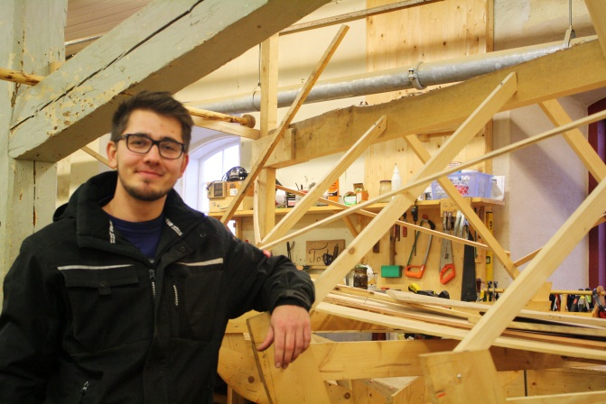
Why a boat building course?
Well, I had a chance to practice at a furniture company but since I already do it at home this was just more interesting. Besides, my boss recommended this course to me.

So how do you like it?
I like it. People are friendly and everyone can speak English (it is not like that in Germany). You are allowed to make mistakes. Work doesn’t really feel like work either, it’s much shorter – at home I start at 6.30 a.m. and finish at 4 p.m.

What is your biggest surprise here?
That school is not so straight.

And what do you think of the city itself?
It is a nice city, not to big, not to small. I liked Marinmuseum. But beer is expensive (laughs).

Intervjuades av Ewa Mostowska

